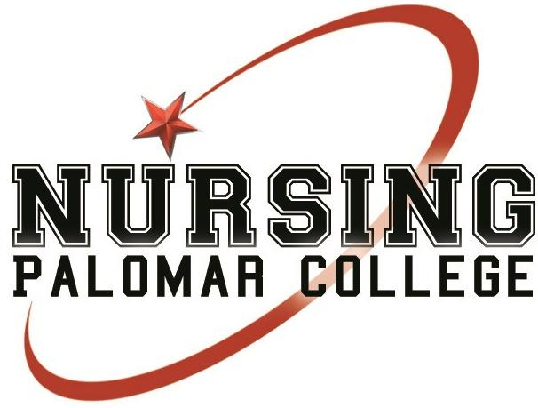
SNAP Registration Form
Name:______________________________________ Graduating Class:_____________________
Address:___________________________________________ City/ZIP:_______________________
Phone Number:______________________ Email:________________________________________

PHOTO CONSENT FORM
I, _________________________________________, grant permission to the Palomar College Nursing Program for the use of photograph(s) or electronic media images in any presentation or Palomar Nursing and Student Nurses Association of Palomar (SNAP) webpage. I understand that I may revoke this authorization at any time by notifying the Nursing Department in writing. Images will be stored in a secure location and only authorized staff will have access to them. They will be kept as long as they are relevant and until such time they will be destroyed or archived.
Name:__________________________________________________________
Email:__________________________________ Phone number:___________________________
Signature:_____________________________________________________ Date:________________

